|  |
| --- |
| *Technical Design Specification* |

|  |  |  |  |
| --- | --- | --- | --- |
|  | Name | Role | Date |
| Author | Raju Lakide | ABAP Technical Consultant | 29-04-2024 |
| Reviewer |  |  |  |

Contents

Index of Changes 3

1. Purpose and objective 4

2. Type of Specification 4

3. Document References 4

4. Technical Design 4

4.1. Technical Design Summary 4

4.2. Data Dictionary 4

4.3. Transaction 4

4.4. Classes 5

4.5. BadI 5

4.6. Other Kind of development 6

4.7. Error Condition Handling 6

4.8. Additional Information 6

Index of Changes

|  |  |  |  |
| --- | --- | --- | --- |
| Date | Version | Description of Change | Author |
| 20-APR-2024 | 2.0 | Based on the PO release date to validate the GRN dates in MIGO transaction | Raju L |
|  |  |  |  |
|  |  |  |  |

# Purpose and objective

# This document describes the technical specification for updating the customer's name in ZBPC_UPLOAD .

# Type of Specification

|  |  |
| --- | --- |
| Program type: | Report (read only)  Update function    Utility  Enhancement (user-exit, BADI, function module)  Modification  SAP GUI Dynpro  Web Dynpro  Interface  Inbound  Outbound  BW extractor |

# Document References

|  |  |  |  |
| --- | --- | --- | --- |
| Ref. | Document Name | Version | Remarks |
|  |  |  |  |

# Technical Design

Technical Design Summary

**Decommission event.**

While doing the MIGO they need a validation against PO first release date

Therefore, we updated the logic to put a validations based on the PO first release date

Based on the Po number, we are passing the po number into erev table and getting the GRNs date and validating the dates

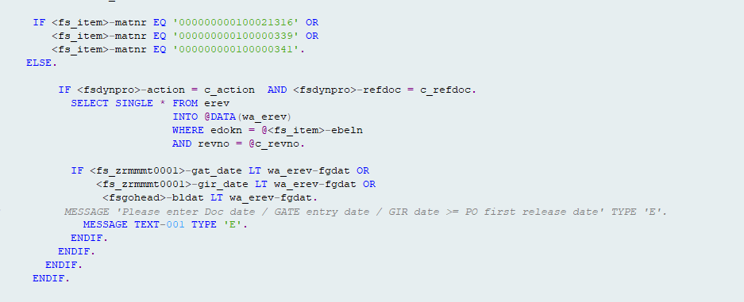

**Transactions:**

**MIGO**

Data Dictionary

n/a

Classes

n/a

BadI

n/a

Other Kind of development

n/a

Error Condition Handling

n/a

Additional Information

n/a